1. Created my own user I: XX_AO_USER from System Administrator Responsibility and assigned responsibilities such as Vision Operation General Ledger, Vision Operation Inventory, and Vision Operation Procurement.

1. Password expiration is set to 60 days

1. This is the 4C Components of a Ledger. They are: Charts of Accounts, Calendar, Currency, and Subledger Accounting Method

1. These are all the Account Code Combinations

1. All Journals with Payables as the Source

1. This is showing the Journal Header Database Table Name. The Database Table Name is: **GL_JE_BATCHES_HEADERS_V**

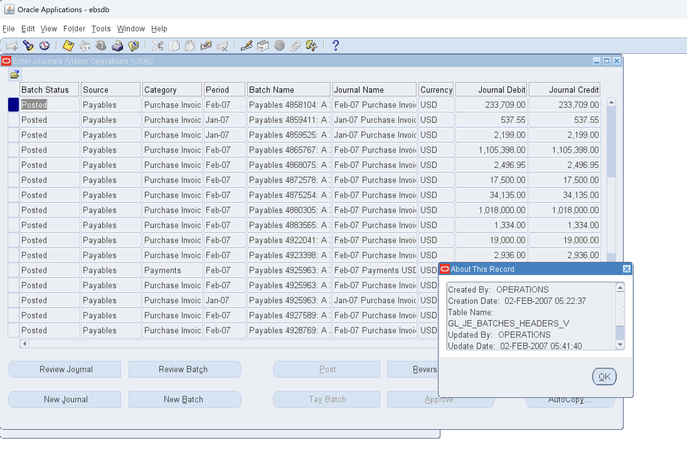

1. This is showing all the one Manual Source

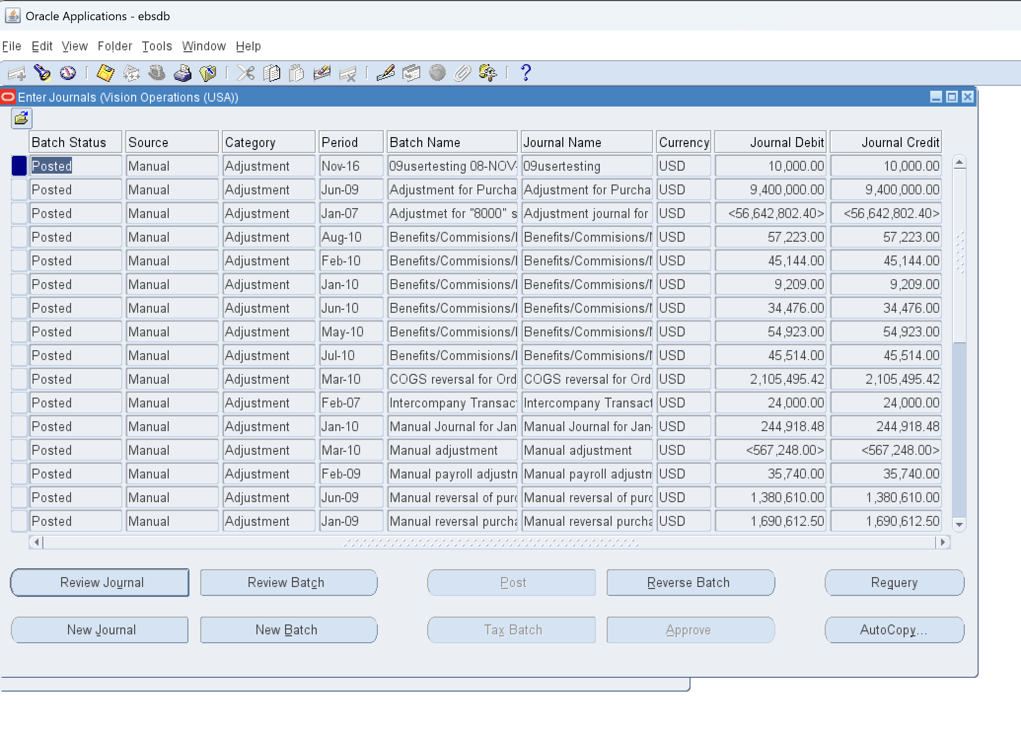

This is showing the one Payables as the Source

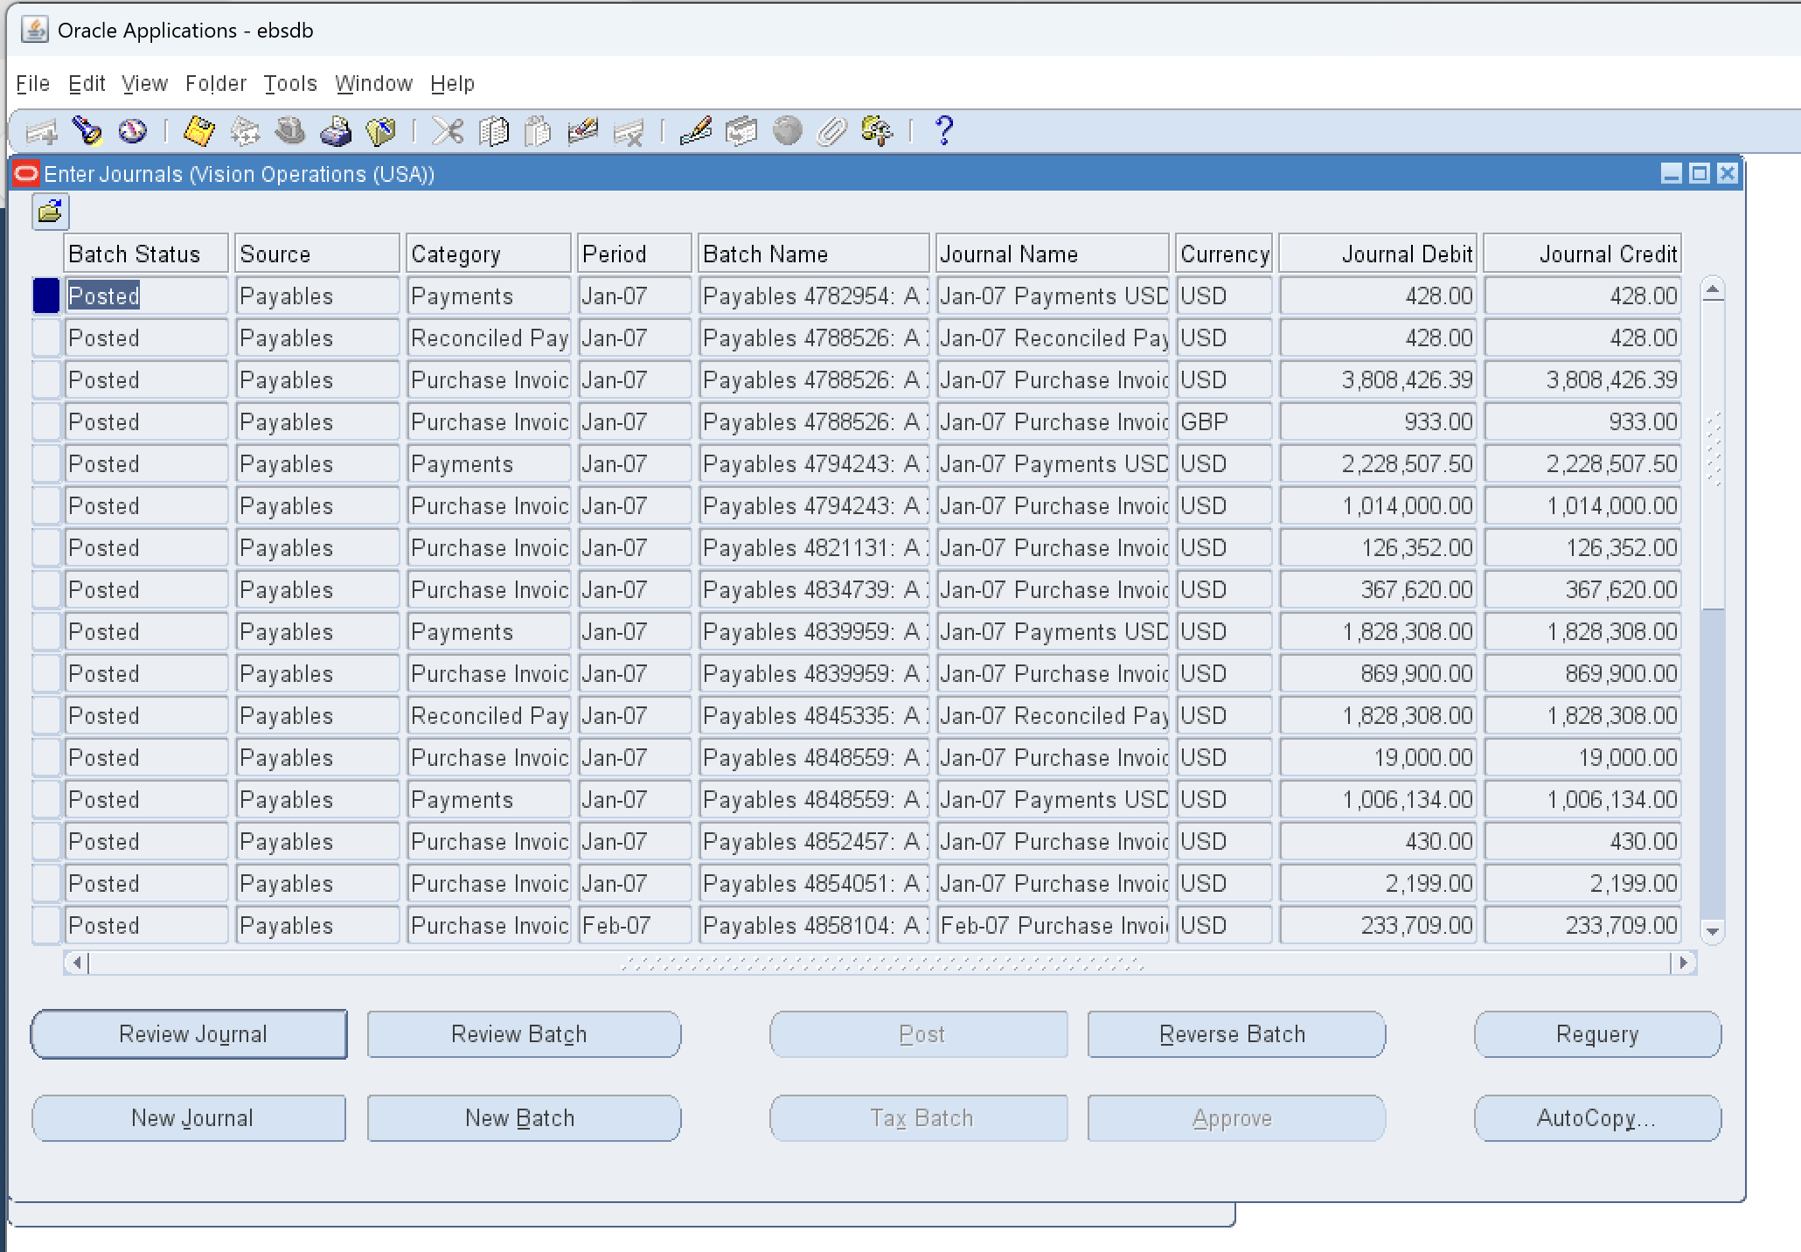

1. This is showing all the posted journal entries in Oracle GL step by step

1. This is showing the Charts of Accounts 9COA) structure in General Ledger

1. This shows how to run one Concurrent Request from General Ledger

1. These are all the common components in all the Ledger

1. There are 4 types of accounts in Oracle Account Code Combination. They are Revenue, Expenses, Liability, and Assets

1. This is showing the Structure of Chart of Account segment structure

